**Assignment:** **Personal Portfolio report**

Submit this document as well as the entire working directory for this assignment on PLATO.

Submit it until 2025.04.14

|  |  |
| --- | --- |
| **Name** | Amartuvshin Boldbaatar |
| **Stu ID** | 202255632 |
| **Dept.** | Computer Science Engineering |
| **Section** |  |

1. Paste a screenshot of your website:

[www.marasu.me](http://www.marasu.me) for demo

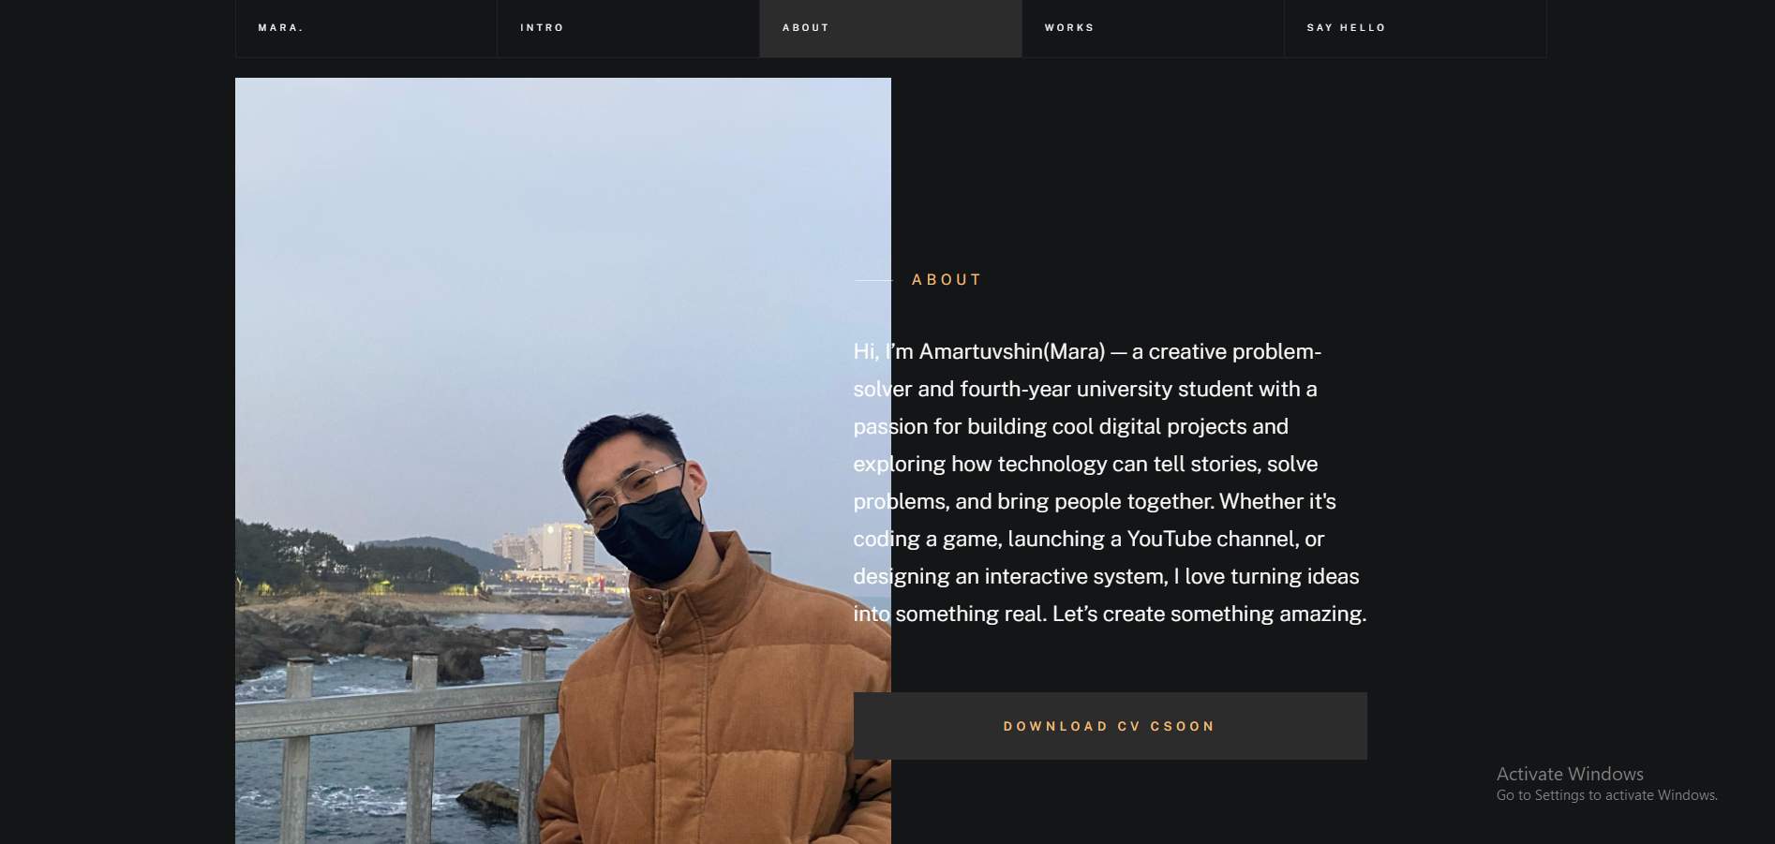

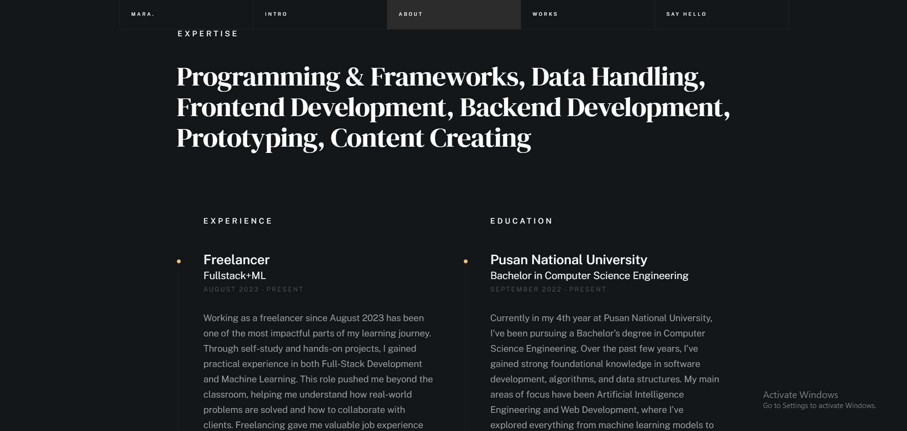

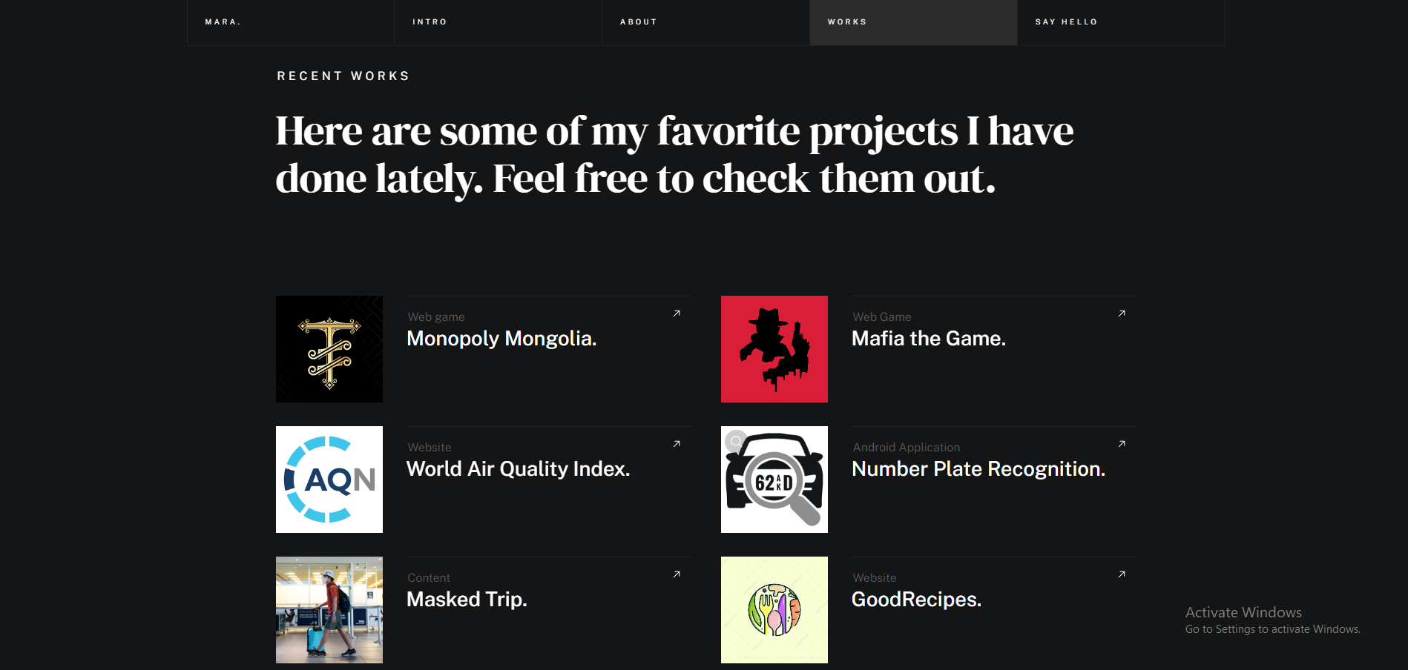

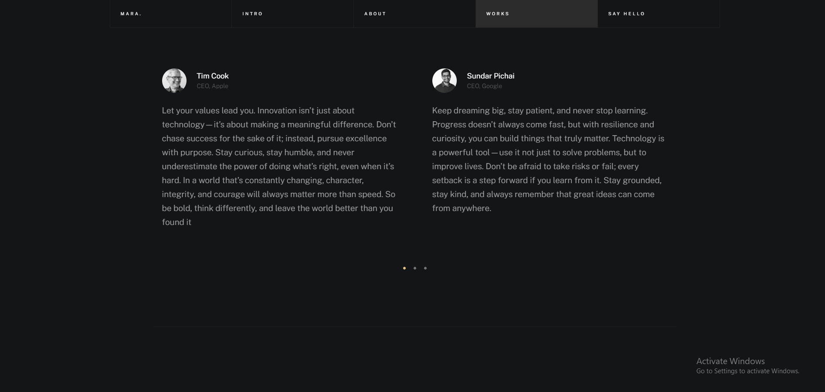

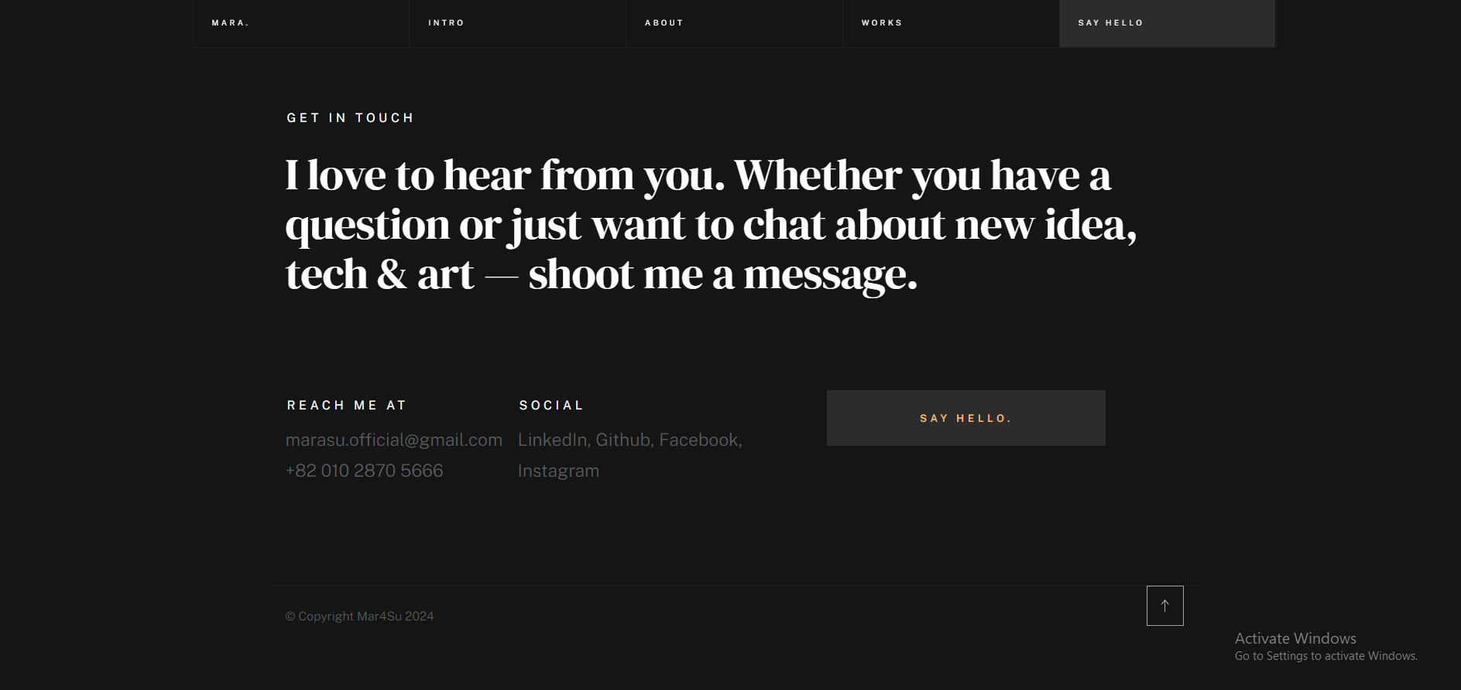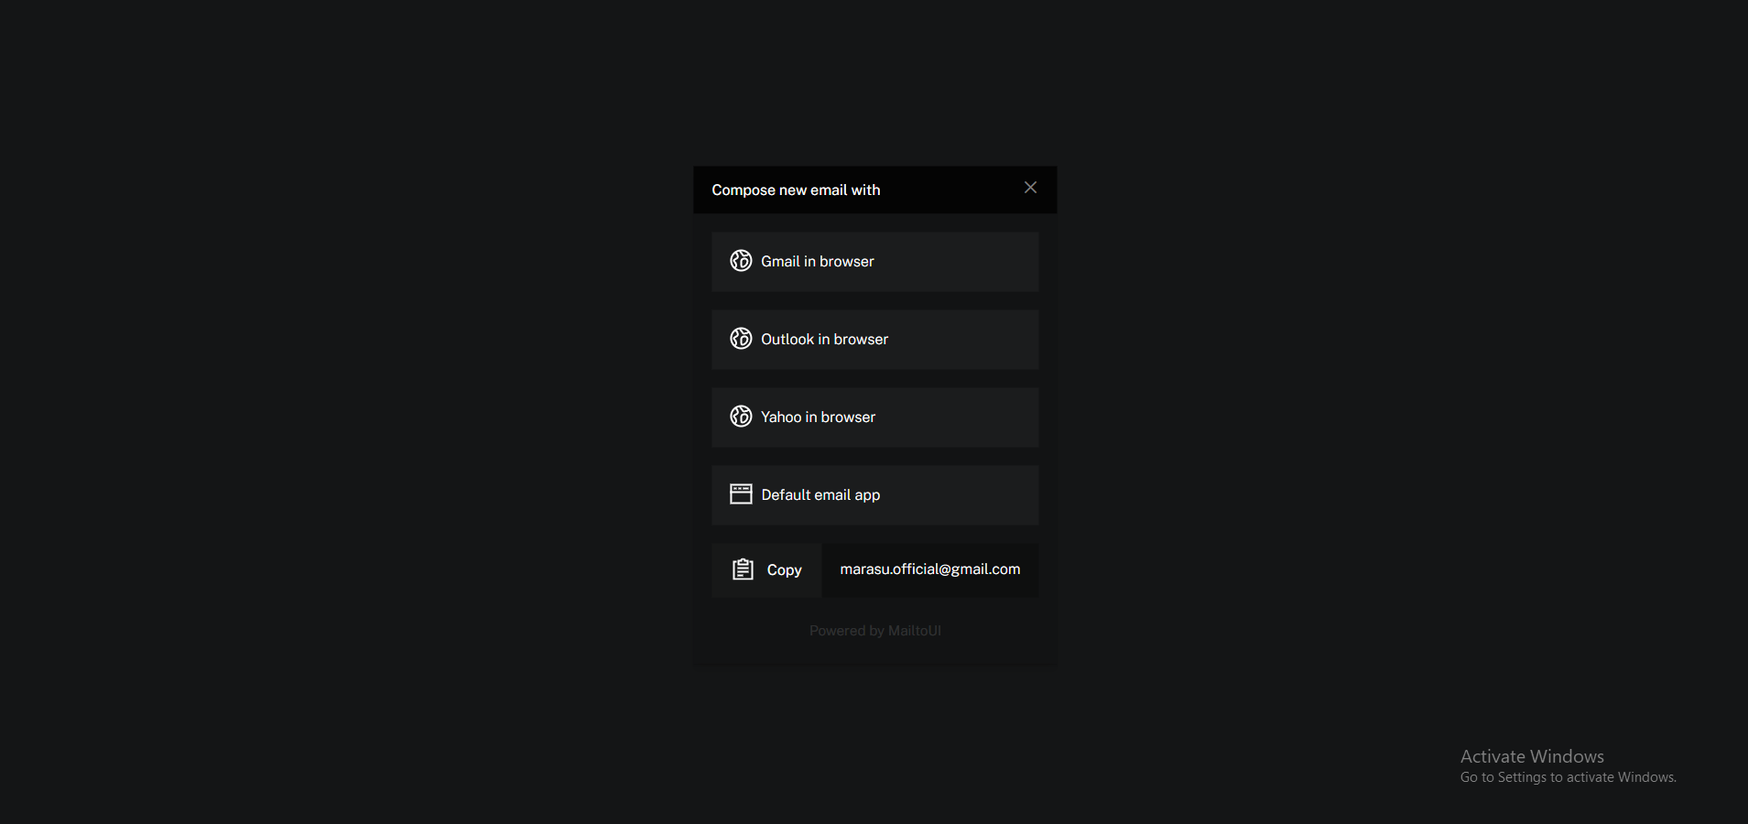

1. Describe the structure of your homepage. How did you structure the layout? Explain the elements you included.

Css:

Styles.css(Personal Stylesheet)

Vendor.css(Third Party Stylesheet)

Images:  
 (Images used in portfolio)

Js:

Main.js(Personal JS)

Plugins(JS plugins for smooth theme and others)

Index.html:

(Main HTML)

1. Paste a screenshot of the HTML and CSS code for your homepage layout. Explain how each section is structured.

For full detailed code ref from: <https://github.com/Mar4Su/Portfolio>  
  
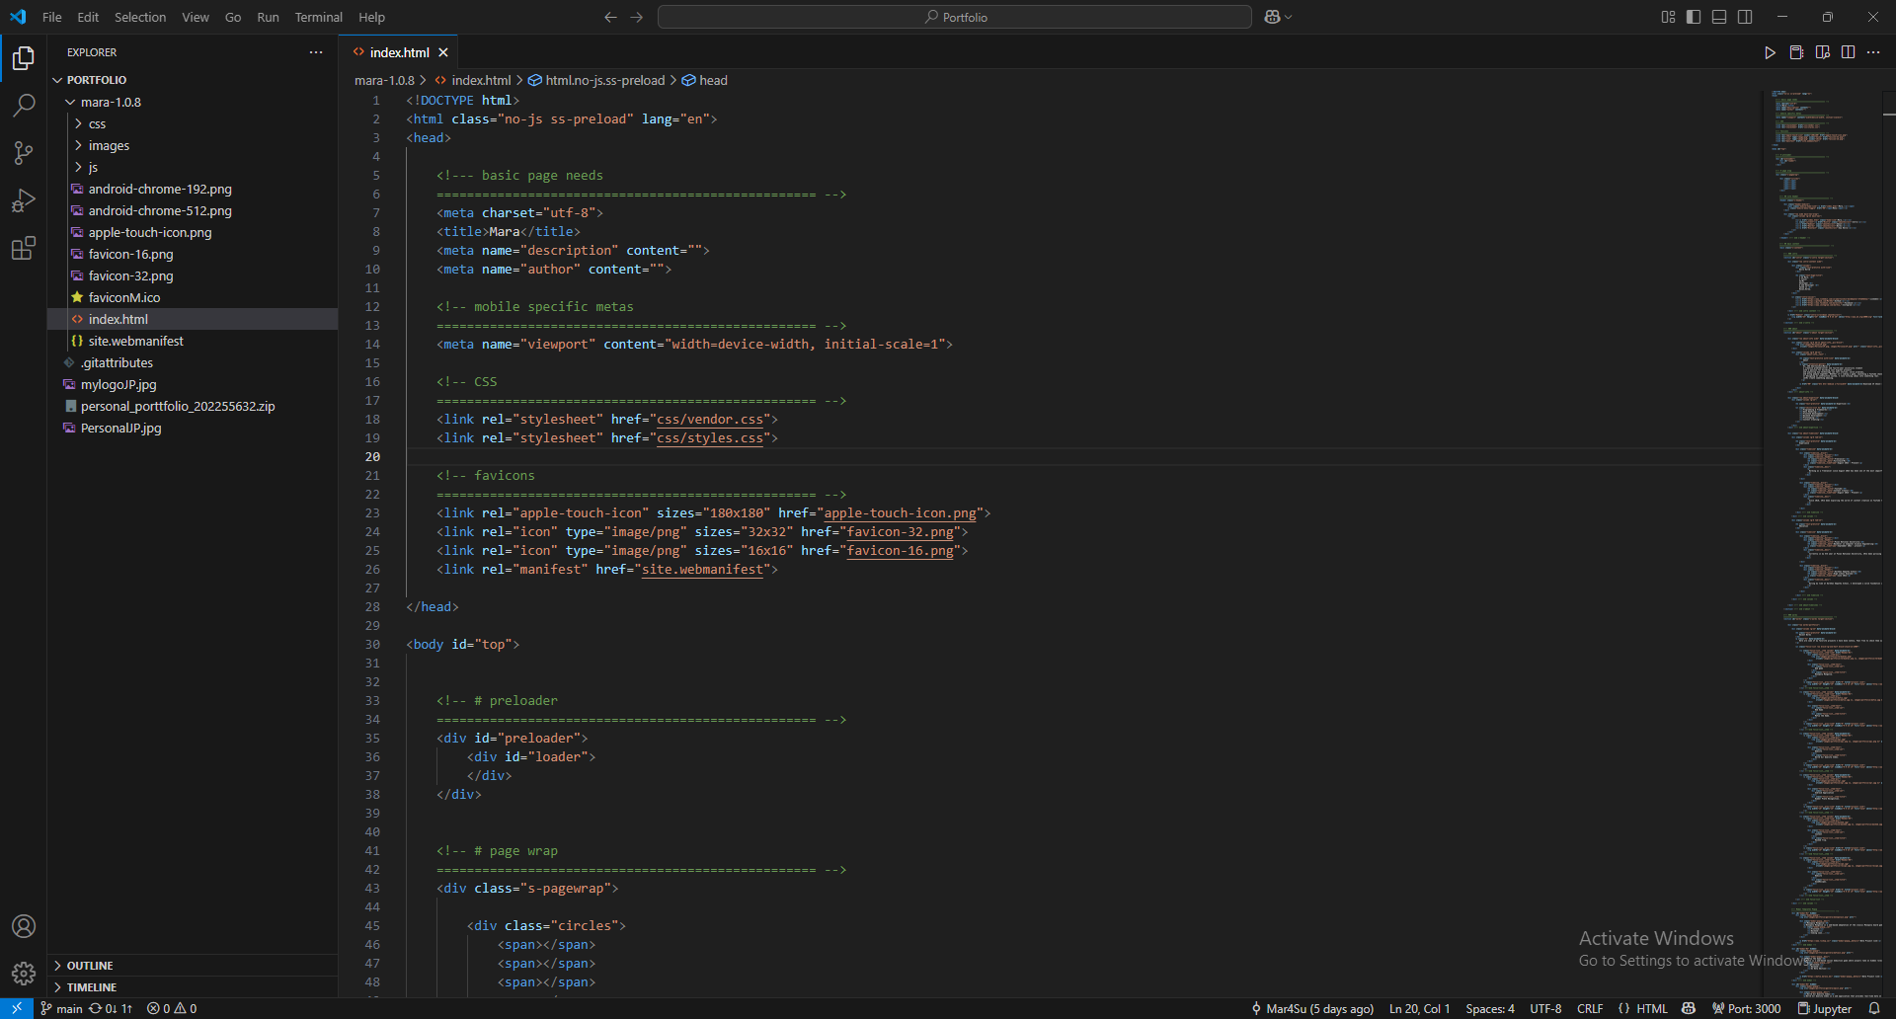

Image1-Initialization

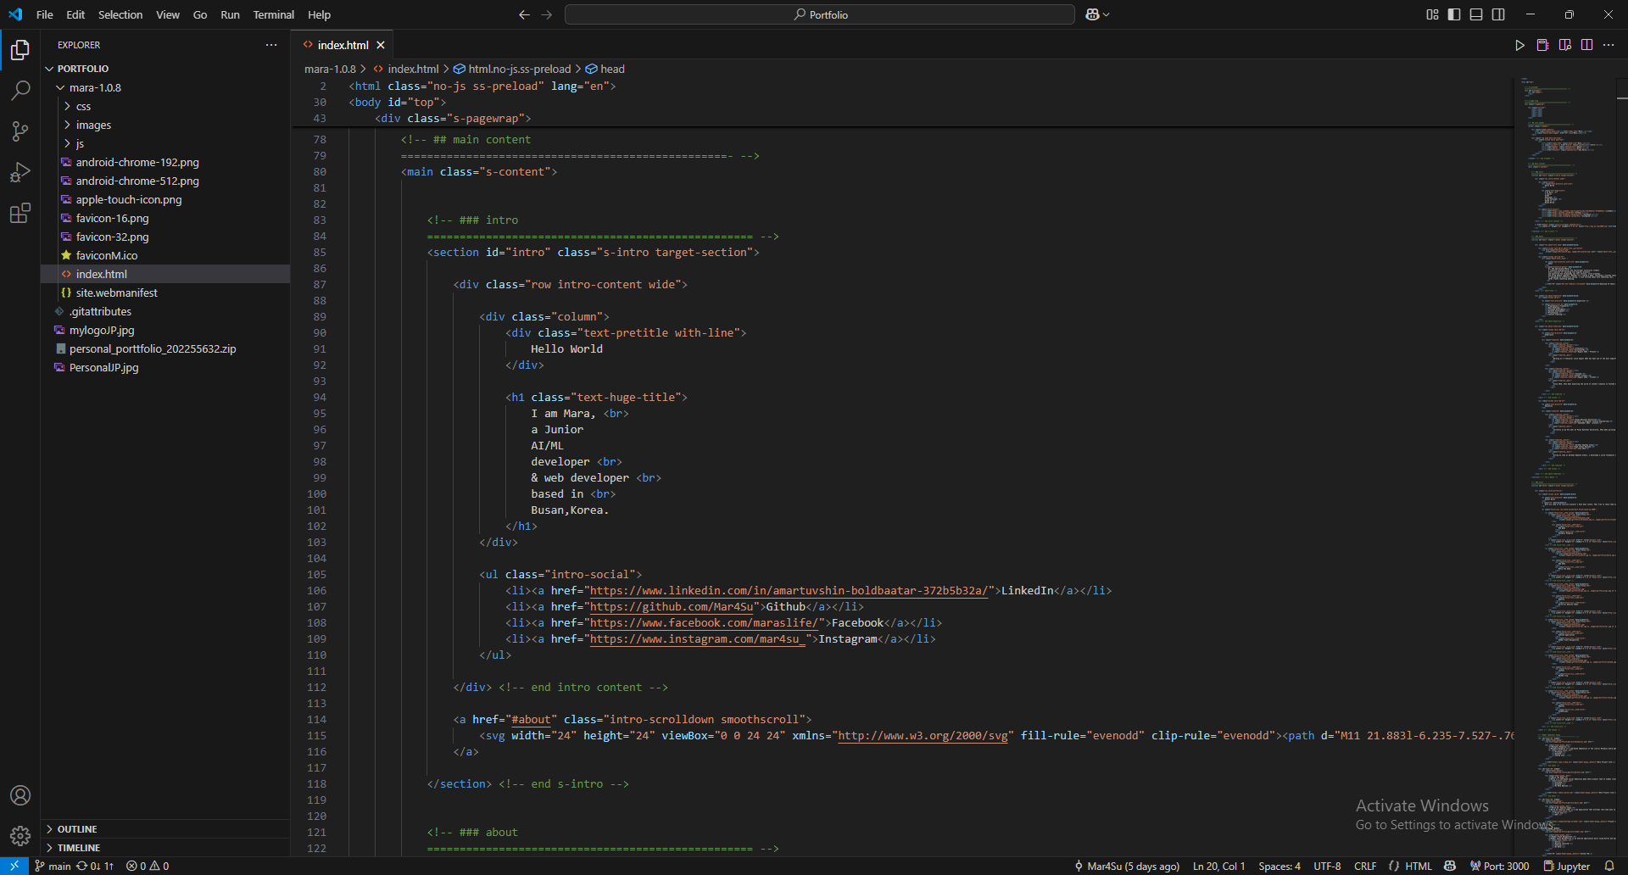

Image 2-Introduction and plugin use

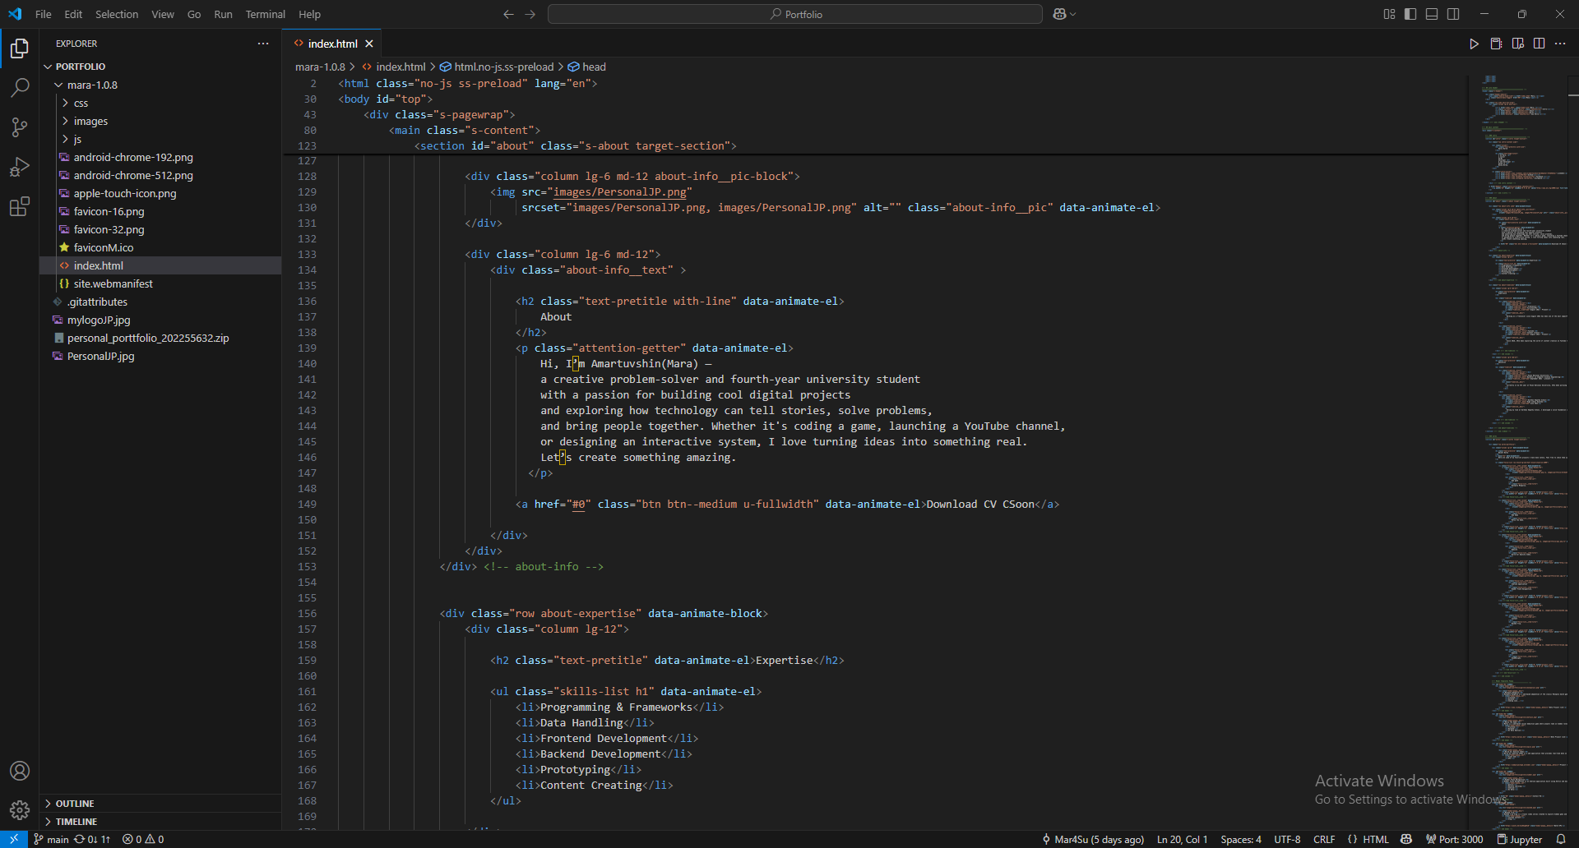

Image 3- About me and photo initialization

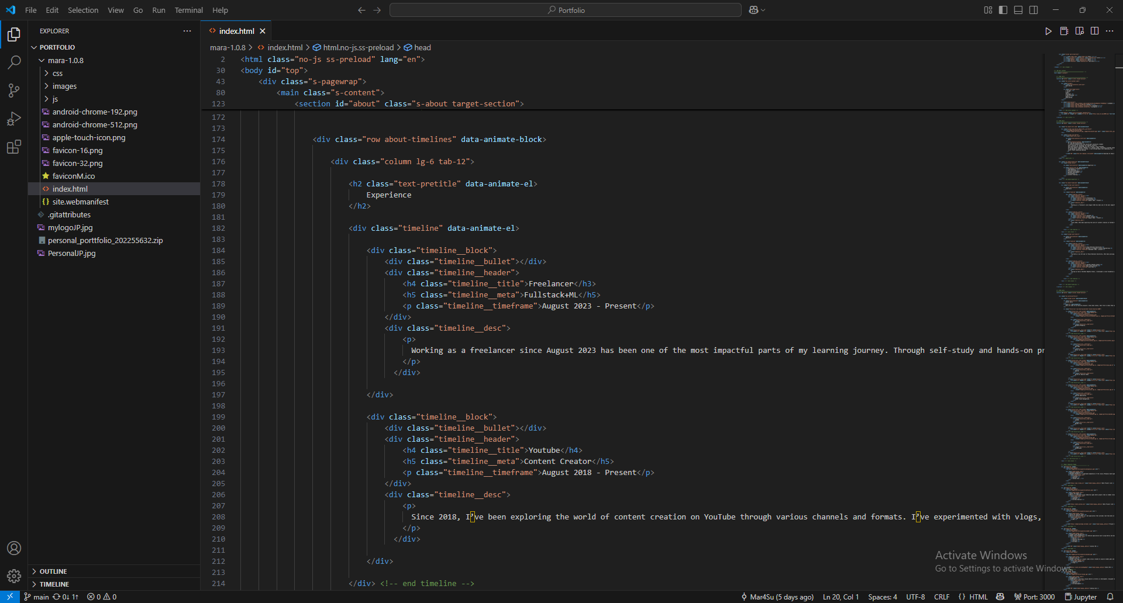

Image 4- Personal experience paragraph using styled class

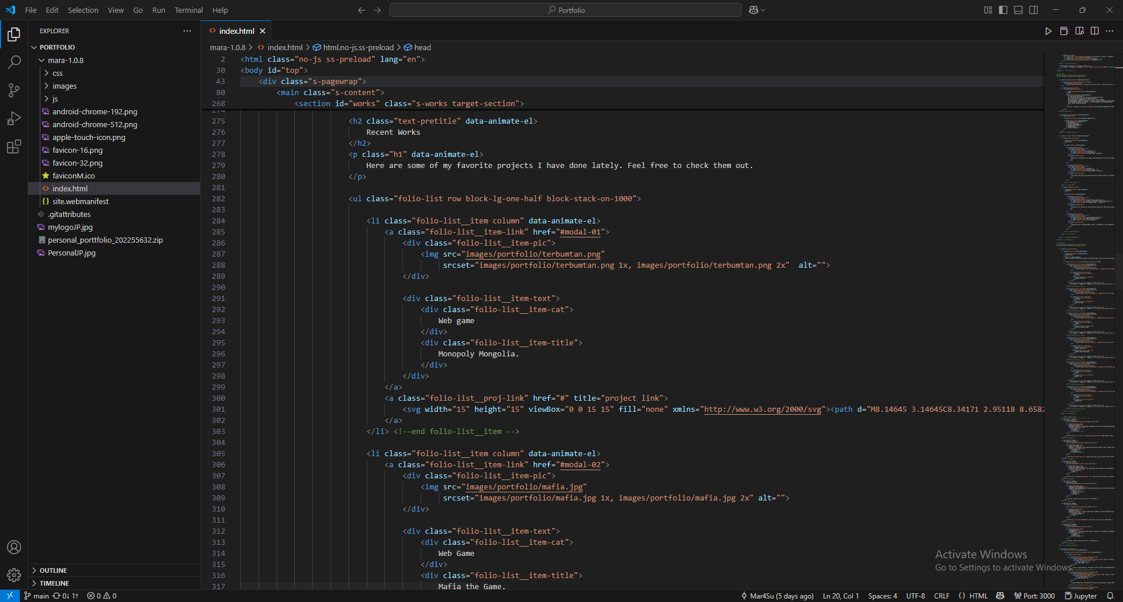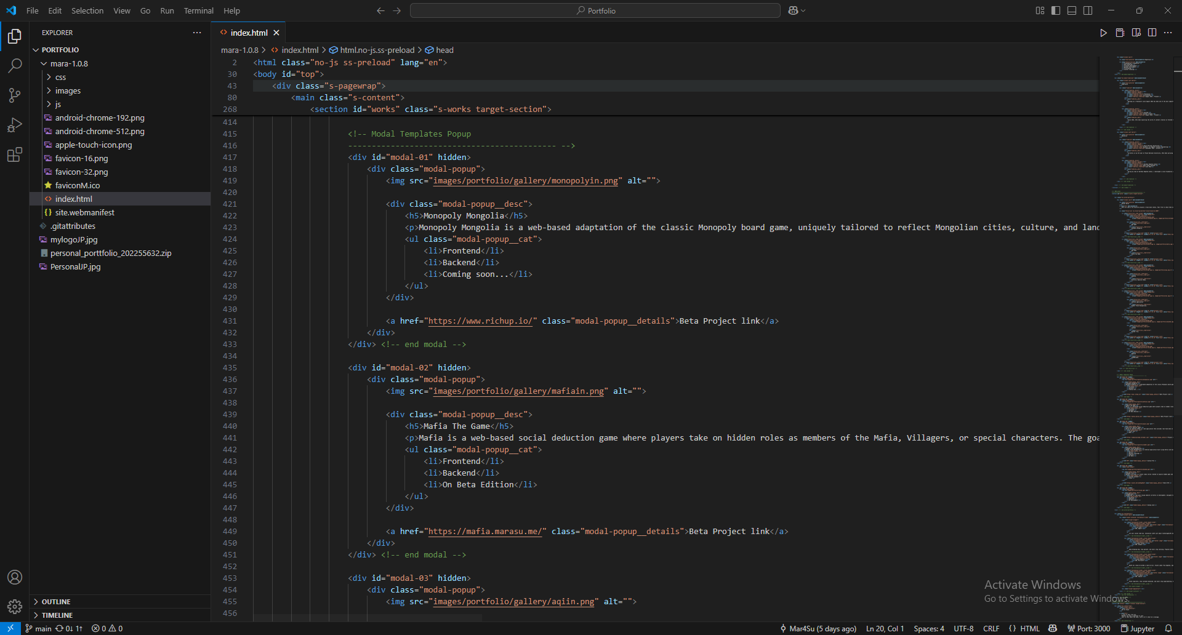

Image 5, 6- Project card and Pop up window link

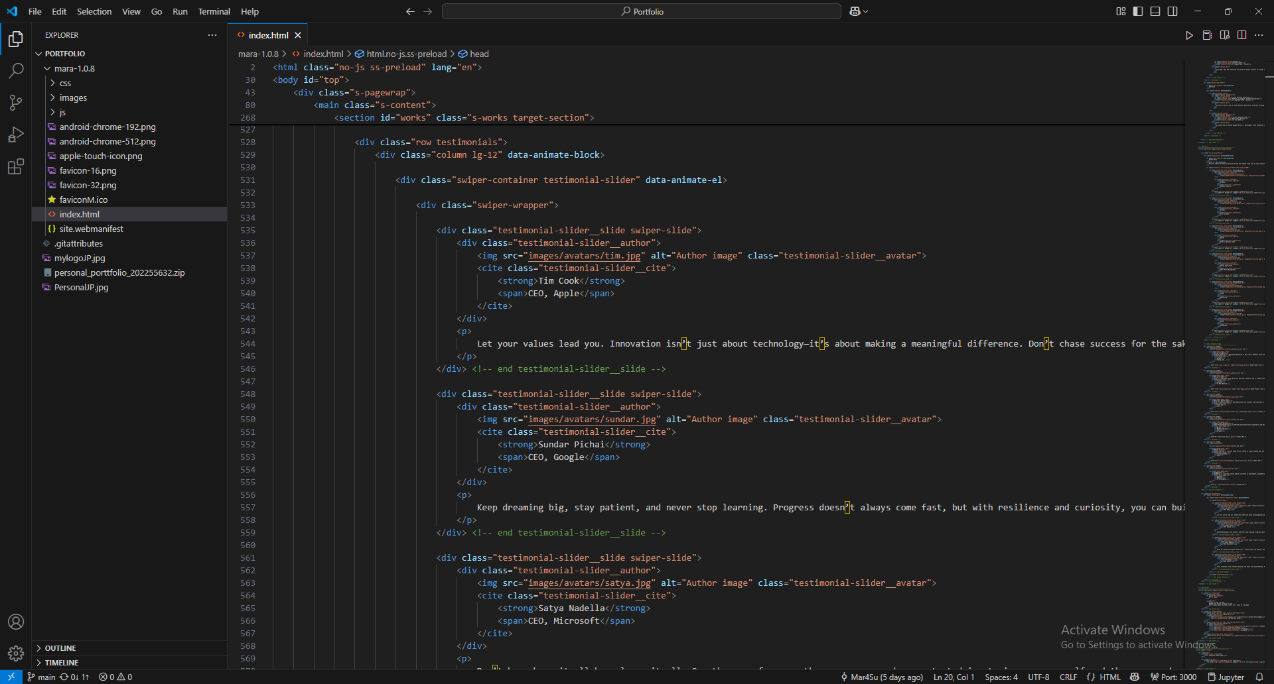

Image 7- Swiper container for motivational quote slides

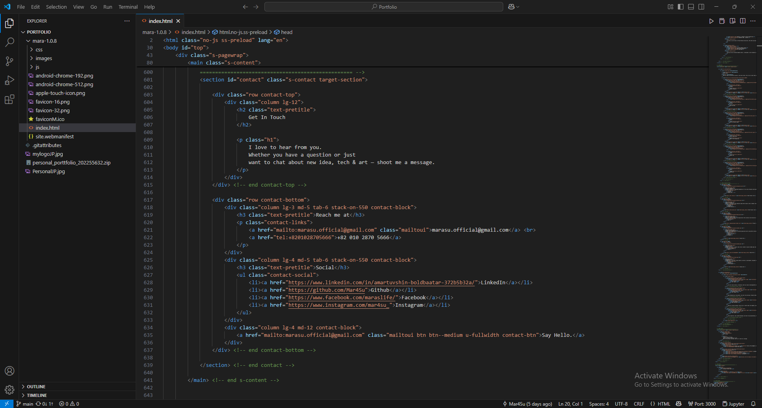

Image 8- Contact me using plugin MailToUI

1. What CSS styling techniques did you use? Paste a screenshot of the section where you used CSS for styling text and layout. Explain how it works.

For style.css

# SETTINGS

 *      ## fonts

 *      ## colors

 *      ## spacing and typescale

 *      ## grid variables

 * # NORMALIZE

 * # BASE SETUP

 * # GRID

 *      ## large screen devices

 *      ## medium screen devices

 *      ## tablet devices

 *      ## mobile devices

 *      ## small screen devices

 *      ## additional column stackpoints

 * # UTILITY CLASSES

 * # TYPOGRAPHY

 *      ## base type styles

 *      ## additional typography & helper classes

 *      ## lists

 *      ## spacing

 * # PRELOADER

 * # FORM

 *      ## style placeholder text

 *      ## change autocomplete styles in Chrome

 * # BUTTONS

 * # TABLE

 * # COMPONENTS

 *      ## pagination

 *      ## alert box

 *      ## skillbars

 *      ## stats tabs

 * # PROJECT-WIDE SHARED STYLES

 *      ## media classes

 *      ## theme-specific typography classes

 *      ## MailtoUI style overrides

 * # PAGE WRAP

 *      ## circles

 * # SITE HEADER

 *      ## main navigation

 *      ## mobile menu toggle

 * # INTRO

 *      ## intro social

 *      ## intro scrolldown

 * # ABOUT

 *      ## about info

 *      ## about expertise

 *      ## about timelines

 * # WORKS

 *      ## works portfolio

 *      ## modal popup

 *      ## testimonials

 *      ## testimonial slider

 * # CONTACT

 * # FOOTER

 *      ## copyright

 *      ## go top

Also I used vendor.css third party stylesheet.

please visit my github for good code reference: <https://github.com/Mar4Su/Portfolio>

also for good demolization please visit my personal web: [www.marasu.me](http://www.marasu.me)

1. What information did you include (e.g., form, email, social media links, images)? Paste a screenshot of the form code. Explain how you structured the information and styled it.

I have included my social media links of LinkedIn, Facebook, Instagram, Github and I linked my other projects. At the end I used MailToUI for contact me section it will automatically open window for mail.

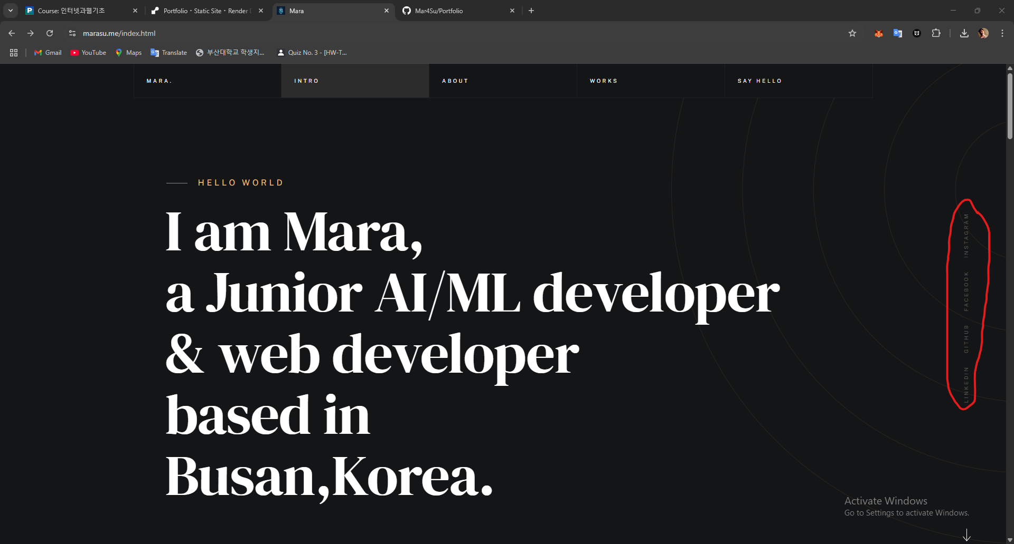

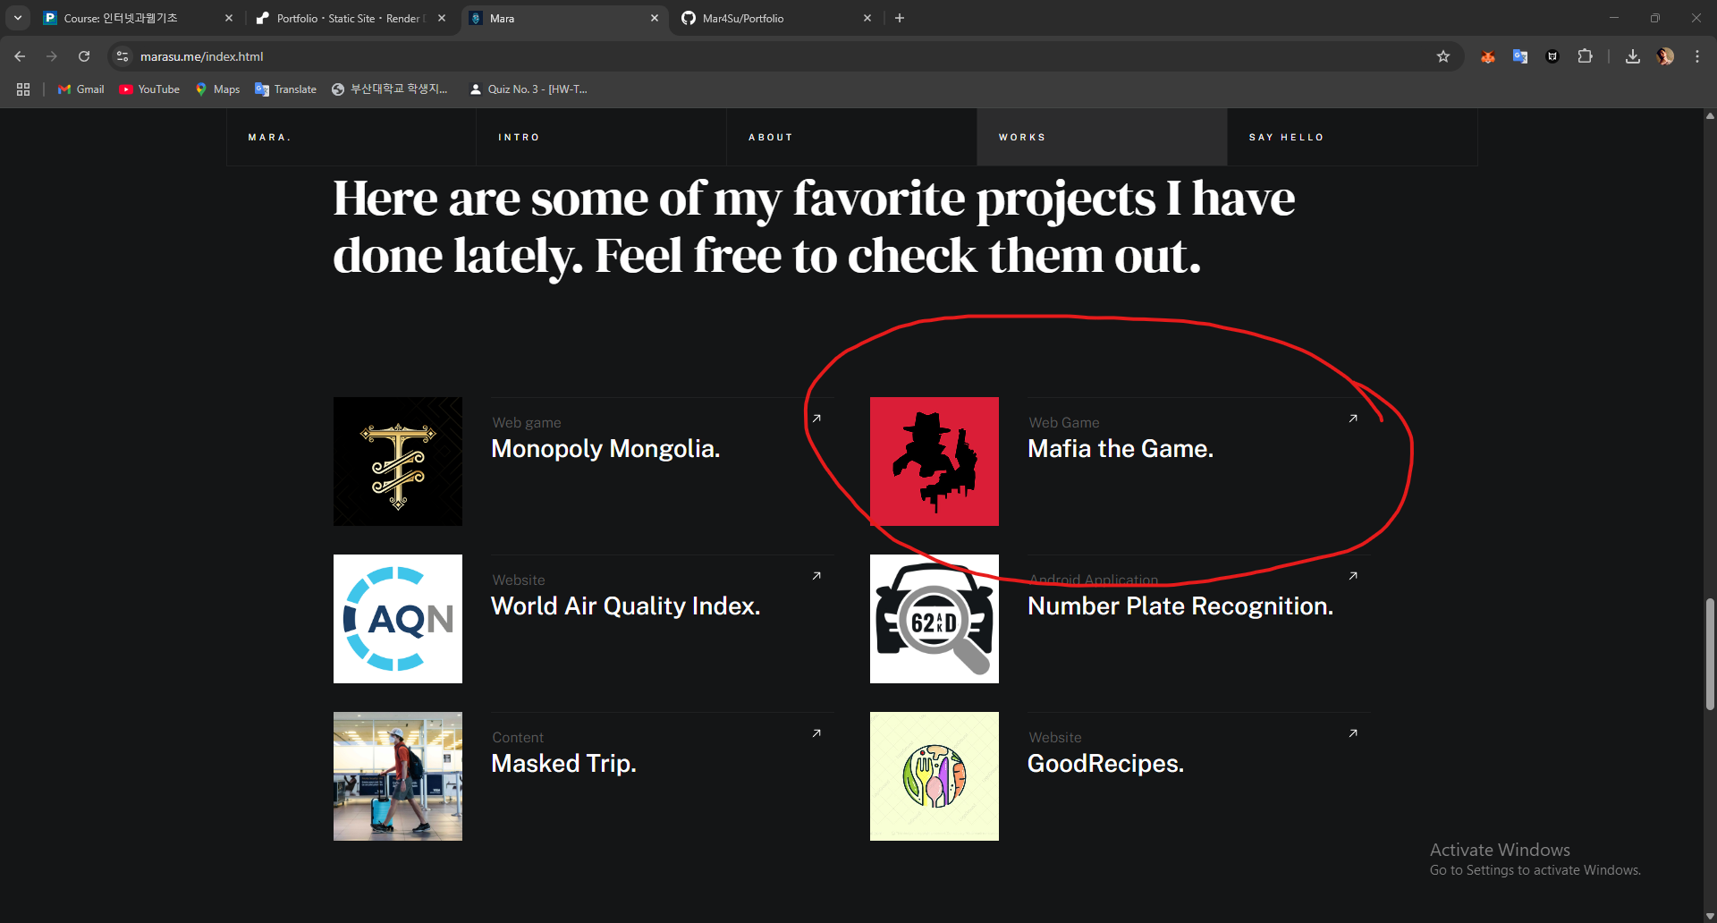

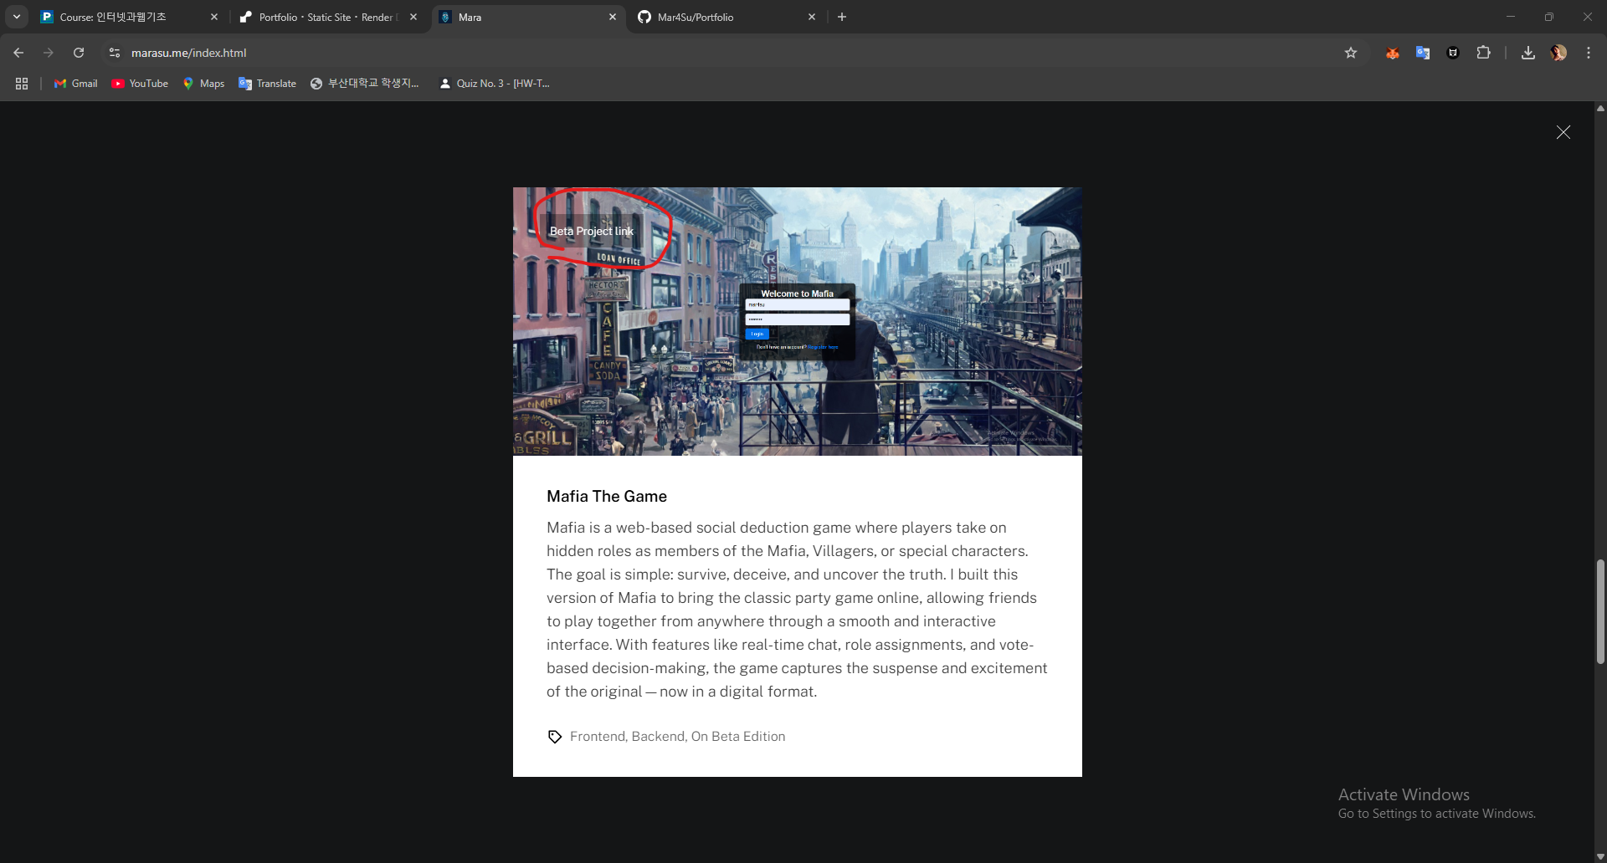

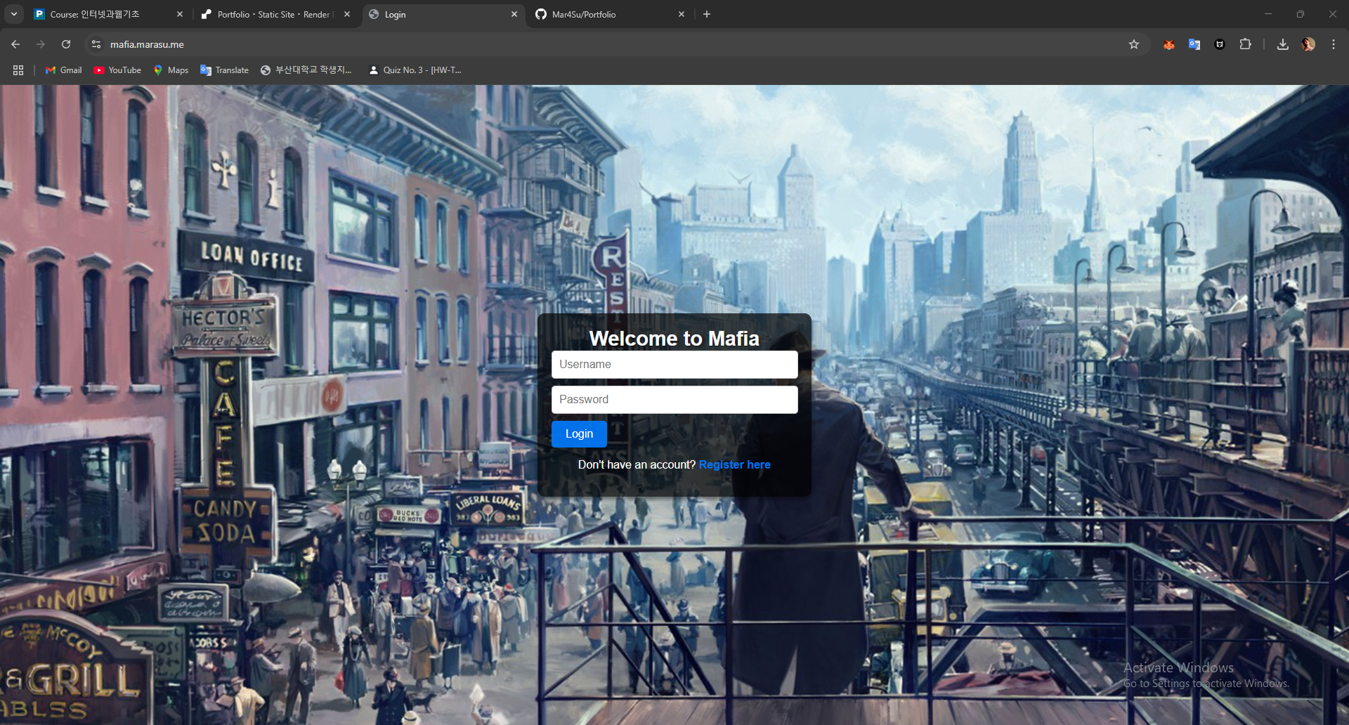

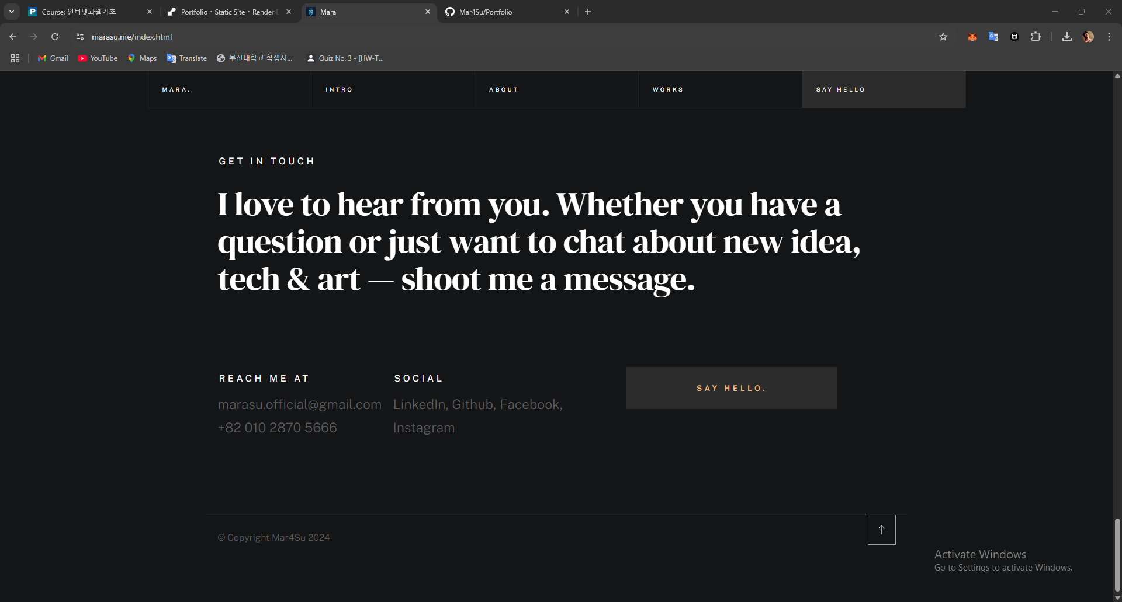

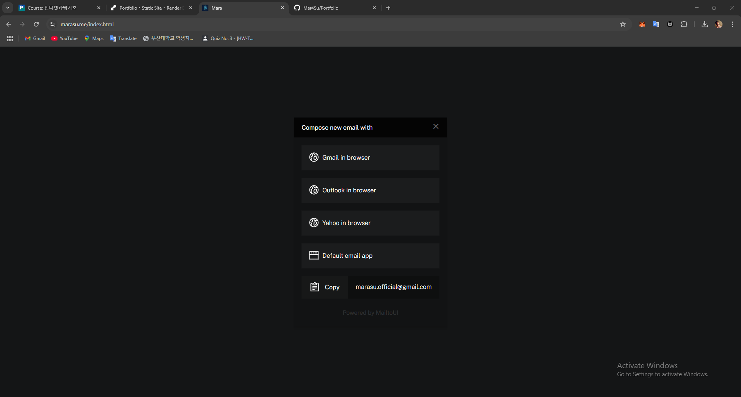

please visit my github for good code reference: <https://github.com/Mar4Su/Portfolio>

also for good demolization please visit my personal web:[www.marasu.me](http://www.marasu.me)